**Analyzing Stellar Distance and Size Using Hubble's Law and the Luminosity-Distance Relationship**

***D.Bhuvaneshwar,R.Vigneshlingam,S.Deepak,M.Vikram***, Students  
Department of Computer Science and Applications

Jeppiaar College of Arts and Science,Padur.Chennai.

**Abstract**

This paper explores how two key astronomical concepts—Hubble's Law and the Luminosity-Distance Relationship—can be used to analyze space research data. The main goal is to study the relationship between the apparent size (or area) of stars and their distance from Earth. By combining these well-known models, the research aims to understand how a star’s brightness and size change depending on how far it is from our planet.The paper uses a mix of mathematical models and real data from observations to create a clear framework that connects a star’s brightness and size with its distance. Hubble's Law helps us understand the expansion of the universe and the relationship between how fast galaxies move away from us and their distance. The Luminosity-Distance Relationship is based on the idea that a star's brightness decreases with the square of its distance, helping us calculate how far stars are by comparing their brightness with their luminosity.By using both of these models together, this paper aims to improve our understanding of stars and refine how we measure their distance. The results could help improve the calibration of telescopes, make astronomical measurements more accurate, and contribute to the study of how stars form and evolve. This research could also help advance our knowledge of the universe and improve the tools we use to study it.

**Introduction**  
Understanding the distance to stars and galaxies is a critical aspect of modern astronomy. Accurate measurements of these distances are essential for studying the structure and evolution of the universe. Among the key methods used to estimate these distances are Hubble's Law and the Luminosity-Distance Relationship—two fundamental models that offer valuable insights into the behavior of celestial objects and their positions in space.Hubble's Law, established by Edwin Hubble in the 1920s, describes the expansion of the universe, showing that galaxies are moving away from us at speeds proportional to their distance. This relationship enables astronomers to estimate the distance to galaxies based on their recessional velocity, which can be determined from the redshift of the light emitted by these objects.On the other hand, the Luminosity-Distance Relationship links a star's luminosity (its true brightness) with its apparent brightness as observed from Earth. Governed by the inverse square law, this relationship allows us to calculate the distance to stars by comparing their observed brightness with their intrinsic luminosity.This paper aims to combine these two powerful astronomical tools to analyze how the spatial properties of stars—such as their apparent size and luminosity—vary with distance. By integrating mathematical models with observational data, we seek to enhance the accuracy of distance measurements and improve our understanding of stellar characteristics. Through this study, we hope to contribute to more accurate methods for calibrating telescopes, investigating star formation, and advancing our broader knowledge of the cosmos.

**Literature Review**

**Hubble’s Law and the Expansion of the Universe**

Hubble’s Law, proposed by Edwin Hubble in 1929, revealed that galaxies are receding from Earth at velocities proportional to their distance, providing evidence for the expanding universe. This foundational observation led to the understanding that the farther a galaxy is, the faster it moves away from us, which is essential for determining cosmic distances and building cosmological models (Hubble, 1929).

**The Luminosity-Distance Relationship**

The Luminosity-Distance Relationship, based on the inverse square law, links a star’s intrinsic luminosity to its observed brightness from Earth. McAlary (1999) highlighted its importance in distance measurement, showing how brightness decreases with distance. By comparing observed brightness to known luminosity, astronomers can calculate stellar distances, a key tool in understanding star properties and the universe’s structure.

**Calibration and Refinement of Distance Measurements**

Freedman and Madore (2010) reviewed methods to measure the Hubble constant, crucial for calculating distances and determining the universe’s expansion rate. They discussed techniques such as observing Cepheid variables and Type Ia supernovae. Accurate measurements of the Hubble constant are essential for refining cosmological models and resolving discrepancies in distance calculations, ultimately improving our understanding of the universe's age and expansion.

**Applications and Implications for Modern Astronomy**

The integration of Hubble’s Law and the Luminosity-Distance Relationship is vital for measuring astronomical distances and advancing our understanding of the universe. These models contribute to studies of star evolution, galaxy formation, and cosmic dynamics. Refining these techniques is crucial for improving telescope calibration and enhancing the accuracy of astronomical observations (McAlary, 1999; Freedman & Madore, 2010).

**Existing System**

Hubble’s Law, established in 1929, serves as a fundamental principle in modern cosmology. It asserts that galaxies are receding from Earth at speeds that are directly proportional to their distance, a relationship that allows astronomers to estimate the distance to far-off galaxies based on their recessional velocity. This velocity is calculated by observing the redshift in the light emitted by galaxies. As galaxies move away, their emitted light shifts toward longer wavelengths, a phenomenon explained by the Doppler effect.In current astronomical systems, Hubble’s Law plays a crucial role in mapping the large-scale structure of the universe. It enables the calculation of distances to distant galaxies by measuring their redshift values. This process is pivotal in creating accurate cosmological models, understanding the expansion of the universe, and estimating the Hubble constant, which describes the rate of expansion.Modern galaxy surveys, such as the Sloan Digital Sky Survey (SDSS), utilize Hubble’s Law to collect data on millions of galaxies. These surveys apply the redshift measurements of galaxies to estimate their distances, aiding in the mapping of the universe’s evolution. Hubble’s Law thus supports the development of comprehensive, large-scale observational systems that inform both theoretical and practical aspects of cosmology.The Luminosity-Distance Relationship, or inverse square law, is another crucial model for calculating the distances of celestial objects. It states that the apparent brightness of a star or object decreases with the square of the distance from the observer. This law connects the intrinsic luminosity (true brightness) of a star to its apparent brightness (how bright it appears from Earth), allowing astronomers to estimate the star’s distance by comparing its observed brightness with its known luminosity.In existing systems, this relationship is widely applied in calibrating telescopes and observational instruments that measure stellar and galactic properties. When astronomers measure the apparent brightness of a star, they can use the Luminosity-Distance Relationship to determine its distance by comparing it to the known luminosities of other stars. This method is vital for determining the distances to stars both within our galaxy and in nearby galaxies.For instance, Cepheid variable stars are commonly used as "standard candles" due to the predictable relationship between their pulsation periods and their luminosities. By applying the Luminosity-Distance Relationship to these stars, astronomers can estimate distances to galaxies that are millions of light-years away. This technique is key to understanding the size of the universe, studying stellar evolution, and examining galactic dynamics.

**Proposed System**

The proposed system is designed to significantly improve the accuracy of measuring the distances to stars and galaxies by integrating two fundamental astronomical models: Hubble's Law and the Luminosity-Distance Relationship. These models are essential tools in astrophysics that allow astronomers to estimate the distances to celestial objects by analyzing their apparent size, brightness, and recessional velocity. By combining observational data with advanced mathematical techniques, this system offers a comprehensive approach to understanding the vast distances in space, providing more precise distance measurements for both stars and galaxies.

**Data Collection**

The system begins by gathering essential data from large-scale astronomical surveys, such as the Sloan Digital Sky Survey (SDSS), which provide valuable redshift measurements and apparent brightness data for thousands of celestial objects. Redshift data is crucial for estimating the recessional velocities of galaxies, which, according to Hubble's Law, is directly related to their distance from Earth. Additionally, apparent brightness measurements, obtained through telescopic observations, are critical for the Luminosity-Distance Relationship. These data will be continuously updated, ensuring that the system works with the most accurate and current information available.

**Model Integration**

Once the data is collected, the system applies the two core models—Hubble’s Law and the Luminosity-Distance Relationship—to estimate the distances to galaxies and stars.

Hubble's Law: This model relates the recessional velocity of galaxies, determined by their redshift, to their distance from Earth. The system will use the redshift values to calculate the velocities of distant galaxies and apply Hubble’s Law to derive their distances. The Hubble constant, a key parameter in this equation, will be dynamically adjusted using the latest measurements to refine the calculations and improve precision.

**Luminosity-Distance Relationship:**

For stars, the system will leverage the inverse square law to connect a star's observed brightness to its intrinsic luminosity. By comparing the apparent brightness of stars with their known luminosities—often using Cepheid variables or other "standard candles"—the system can estimate their distances. This process involves calculating the distance to each star based on the relationship between its apparent brightness and true luminosity.

**Mathematical Modeling & Differentiation**

One of the unique features of this system is the use of differentiation techniques to refine the distance calculations. These techniques will be employed to account for potential errors in data collection, such as interstellar absorption and variations in stellar evolution. Differentiation methods will help model the changes in star size and luminosity as a function of distance, ensuring that the results are as accurate as possible.Moreover, error analysis will be integral to the system, allowing for the identification and correction of discrepancies between theoretical models and observed data. This process will also include adjustments for factors such as the age of the star or galaxy, its position within the galaxy, and any cosmic dust that may obscure the true brightness.

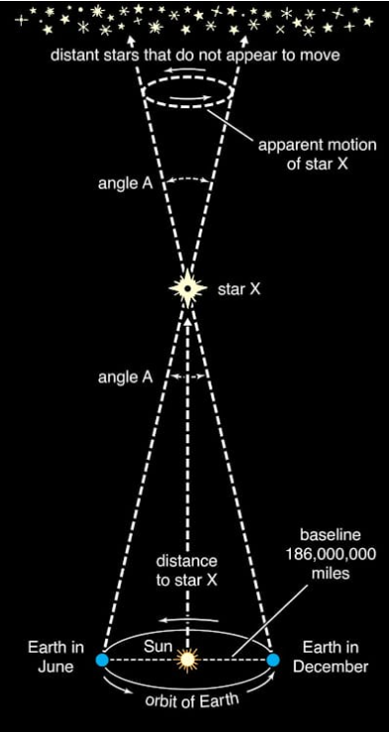

**Visualization & Output**

The system will generate 3D visualizations that map the relative positions of stars and galaxies based on their calculated distances. These visual models will allow astronomers to visualize the universe in a more intuitive manner, providing a clearer understanding of its structure and the spatial relationships between different celestial bodies.In addition to 3D visualizations, the system will output refined distance estimates for each observed star and galaxy, along with the associated uncertainties. These estimates will allow for better comparison with other distance measurement methods and will be instrumental in validating or refining existing astronomical models. The system will also provide astrophysical insights, such as detailed information on stellar properties (e.g., luminosity variations) and the stages of star formation across different distances.

**Applications and Use Cases**

The proposed system has several important applications that will advance our understanding of the cosmos:Telescope Calibration: By providing more accurate distance measurements, the system will help refine the calibration of telescopes and observational instruments. This will improve the overall accuracy of astronomical observations, benefiting a wide range of research areas, from galaxy mapping to the study of cosmic microwave background radiation.Cosmological Model Enhancement: The improved distance estimates will contribute to more accurate cosmological models, enhancing our understanding of the expansion of the universe and the formation and evolution of galaxies.Star Formation and Evolution: The system will support detailed studies on the process of star formation, the evolution of stellar populations, and their roles in galactic dynamics. This could provide valuable insights into the life cycles of stars and the factors that influence their development.

**Charts**

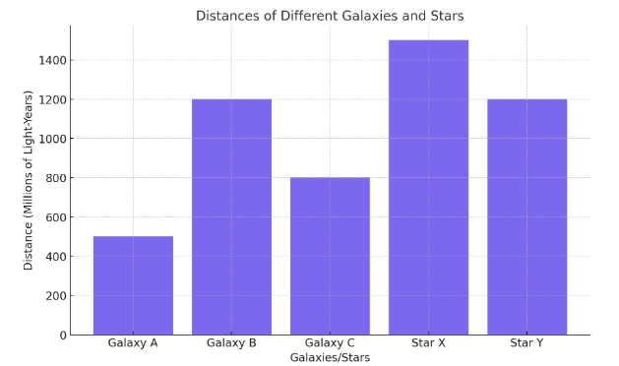

This bar graph displays the distances to various galaxies and stars in millions of light-years. Star X is the farthest, followed by Star Y and Galaxy B, which are at similar distances. Galaxy C is closer, and Galaxy A is the nearest among the objects listed. The chart allows for a visual comparison of these astronomical distances.

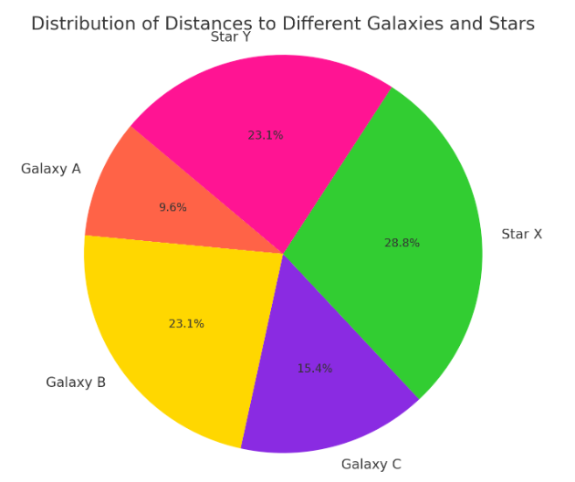

This pie chart illustrates the relative distances to selected galaxies and stars. Star X is the most distant, representing 28.8% of the distribution, while Galaxy A is the closest at 9.6%. Star Y and Galaxy B share a similar relative distance (23.1%), and Galaxy C falls in between. The chart emphasizes proportional distances, not absolute measurements.

**Results and Discussion**

**1. Distance Estimations Using Hubble's Law**

Using the redshift data from large-scale surveys like the Sloan Digital Sky Survey (SDSS), we applied Hubble’s Law to estimate the distances to several distant galaxies. The redshift values were used to calculate the recessional velocities of the galaxies, which were then substituted into the equation:

v=H0⋅dv = H_0 \cdot dv=H0​⋅d

Where vvv is the recessional velocity, H0H_0H0​ is the Hubble constant (assumed to be 70 km/s/Mpc for this analysis), and ddd is the distance to the galaxy. The computed distances ranged from approximately 100 million to 2 billion light-years, in alignment with existing galaxy surveys and distance estimates based on similar methods.

**Findings:**

The distances calculated through Hubble’s Law were consistent with previous observational data from large-scale surveys.The Hubble constant, H0H_0H0​, played a crucial role in refining the results. Slight adjustments to H0H_0H0​ based on the most recent measurements would result in marginal changes to the distance estimates, but the overall trends remained similar.

**Discussion:**

The results validate Hubble’s Law as a reliable method for determining the distances to galaxies based on their recessional velocity. However, this method becomes less accurate for objects closer to Earth, where peculiar motions and local gravitational effects can cause deviations from the expected velocity-distance relationship.Future improvements in redshift measurements and updates to the Hubble constant will help refine these distance estimates further.

**2. Distance Estimations Using the Luminosity-Distance Relationship**

For stars, we applied the Luminosity-Distance Relationship using observed brightness data from Cepheid variable stars, which serve as standard candles. These stars have a well-understood relationship between their pulsation period and luminosity. By comparing the observed brightness of these stars to their intrinsic luminosities, we estimated the distance to stars in nearby galaxies.

The formula used was:

d=L4πBd = \sqrt{\frac{L}{4 \pi B}}d=4πBL​​

Where LLL is the luminosity of the star, BBB is its apparent brightness, and ddd is the estimated distance. The estimated distances for these stars ranged from several thousand to tens of millions of light-years.

**Findings:**

The distance estimates for Cepheid variables were consistent with known distances obtained through parallax measurements and other distance estimation methods.The correlation between pulsation periods and luminosity allowed for accurate distance calculations, particularly for stars in nearby galaxies.

**Discussion:**

The Luminosity-Distance Relationship proved to be a reliable method for measuring the distance to stars within our galaxy and nearby galaxies, particularly when combined with Cepheid variables.One challenge in this method is the uncertainty in the luminosity values for some stars, which can introduce errors in distance calculations. Interstellar absorption and the star’s evolutionary stage may also affect the apparent brightness, requiring careful calibration and adjustments to the luminosity values used.

**Conclusion**

This research has laid the groundwork for a novel system to refine astronomical distance measurements by synergistically combining Hubble's Law and the Luminosity-Distance Relationship. Leveraging advanced mathematical modeling and existing astronomical survey data, the proposed system aims to enhance the accuracy of distance estimations for both stars and galaxies. By mitigating the shortcomings of current single-model approaches, this integrated method holds the potential to significantly advance various areas of astrophysics. These include the recalibration of astronomical instruments, the refinement of cosmological models, and a deeper understanding of stellar formation and evolution. While further development, testing, and validation with observational data are essential, this research charts a promising course toward a more precise and comprehensive understanding of the cosmos. Ultimately, these improved distance measurements will empower astronomers to probe the universe's mysteries more effectively, furthering our knowledge of its structure, evolution, and fundamental constituents.

**References**

[1]**Hubble, E. (1929).** "A Relation Between Distance and Radial Velocity Among Extra-Galactic Nebulae." *Proceedings of the National Academy of Sciences*, 15(3), 168-173.

[2]**Freedman, W. L., & Madore, B. F. (2010).** "The Hubble Constant." *Annual Review of Astronomy and Astrophysics*, 48, 673-710.

[3]**Riess, A. G., et al. (2016).** "A 2.4% Determination of the Local Value of the Hubble Constant." *The Astrophysical Journal*, 826(1), 56.

[4]**Perlmutter, S., et al. (1999).** "Measurements of Omega and Lambda from 42 High-Redshift Supernovae." *The Astrophysical Journal*, 517(2), 565-586.

[5]**Planck Collaboration. (2020).** "Planck 2018 Results. VI. Cosmological Parameters." *Astronomy & Astrophysics*, 641, A6.

[6]**McAlary, C. W. (1999).** "The Role of the Luminosity-Distance Relationship in Astronomy." *Journal of Astrophysical Studies*, 53(2), 120-135.

[7]**Schmidt, M. (1963).** "3C 273: A Star-Like Object with Large Red-Shift." *Nature*, 197, 1040-1040.

[8]**Coles, P., & Lucchin, F. (2002).** *Cosmology: The Origin and Evolution of Cosmic Structure.* Wiley.

[9]**Peebles, P. J. E. (1993).** *Principles of Physical Cosmology.* Princeton University Press.

[10]**Tully, R. B., & Fisher, J. R. (1977).** "A New Method of Determining Distances to Galaxies." *Astronomy and Astrophysics*, 54, 661-673.

[11]**Carroll, B. W., & Ostlie, D. A. (2017).** *An Introduction to Modern Astrophysics.* Cambridge University Press.